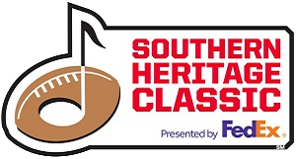
TAILGATE & RV INFORMATION
SIMMONS BANK LIBERTY STADIUM
TAILGATE SPACES ON SALE
Friday April 24, 2026 @ 10:AM CT
AVAILABLE ONLINE AT WWW.TICKETMASTER.COM

PROPERTY LOCATION

- The tailgate property is in midtown Memphis, Tennessee and is bordered on the South by Southern Avenue, on the west by East Parkway, on the east by Hollywood Street, and the north by Central Avenue.

- Access 4 is located on Glenn Rogers Sr St. (formerly S Hollywood St.) is a Credentialed Entrance ONLY

- Access 7 onto the property is at the intersection of Central Avenue and Early Maxwell Street RV LOT and LOT 14 Entrance ONLY.

- Accesses 8 and 9 are located on East Parkway, this is Tiger Lane Tailgate Entrance ONLY.

- Access 11 is at the intersection of Southern Avenue and Early Maxwell Street Tan Lot Tailgate Entrance ONLY.

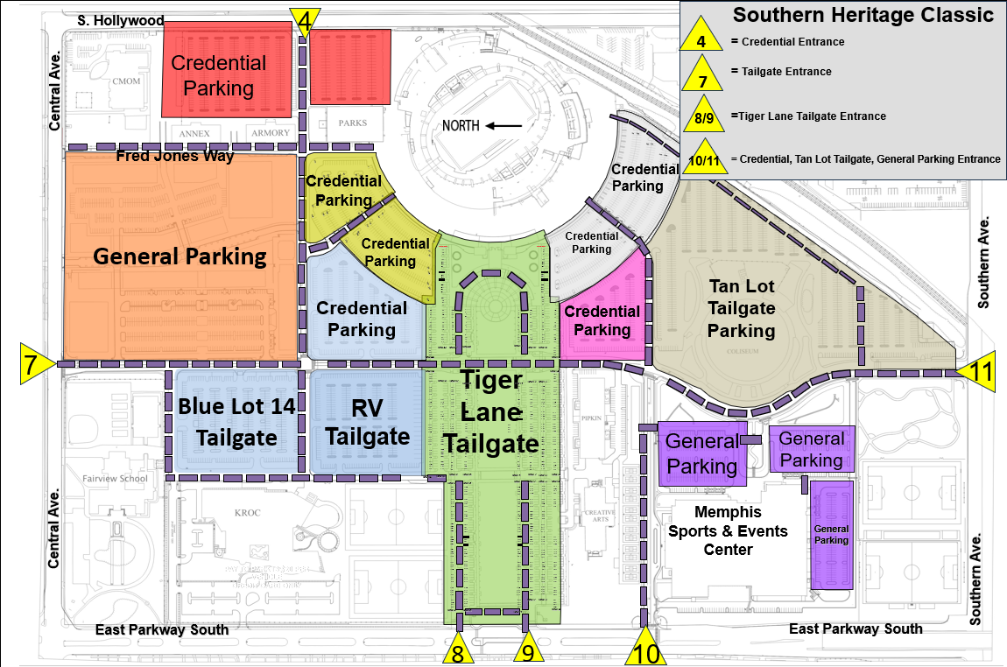
- Please go to Google Maps for directions to Simmons Bank Liberty Stadium, 335 Glenn Rogers Sr. St., Memphis, TN 3810
AVAILABLE TAILGATE SPACES

Tiger Lane – Lots A, B, D, & E

Tiger Lane has a limited number of 20 ft. x 40 ft. paved spaces with 10 ft. x 40 ft. adjacent grass space and 110v electrical connections.
These spaces are sold as premium packages for $568 each.
Each package includes 16 game tickets and choice of team side
is on a first - come, first - served basis.
Entry point for Tiger Lane is Access 8 or 9 off East Parkway

Tiger Lane – Lots C & F
Tiger Lane has a limited number of 20 ft. x 20 ft. paved spaces with a 10 ft. x 20 ft. adjacent grass space and 110v electrical connections.

These spaces are sold as premium packages for $330 each.
Each package includes 10 game tickets and choice of team side
is on a first - come, first - served basis.
Entry point for Tiger Lane is Access 8 or 9 off East Parkway.
Lot 14 – North

Lot 14 has a limited number of 20 ft. x 40 ft. paved spaces.

These spaces are sold as packages for $198 each.
Each package includes 6 game tickets and choice of team side
is on a first - come, first - served basis.

Entry point for Lot 14 is Access 7 at the intersection of Central and Early Maxwell.
RV Lot 15 – North

RV (Electrical)
Lot 15 has a limited number of 18 ft. x 40 ft. paved RV spaces with 18 ft. x 15 ft. adjacent grass space. Each RV shares a Powerhouse utility station with another RV. Each Powerhouse provides a maximum of 2x 50 AMP and is equipped with one 3 wire, 125-volt outlet and one 4 wire 125/250v AC, 60 HZ outlet.

These spaces are sold as packages for $334 each.
Each package includes 8 game tickets and choice of team side
is on a first - come, first - served basis.

RV (Non-Electrical)
Lot 15 also has a limited number of 20 ft. x 40 ft. paved RV spaces without electrical service.

These spaces are sold as packages for $284 each.
Each package includes 8 game tickets and choice of team side
is on a first - come, first - served basis.

This lot is intended for RVs; however, an accompanying vehicle with proper pass will be allowed. All other vehicles must be parked in General Parking or in an alternate tailgating lot.
Entry point for Lot 15 is Access 7 at the intersection of Central and Early Maxwell.

Lot 13 – South

The southeast Coliseum area has a limited number of paved 20 ft. x 40 ft. spaces.

These spaces are sold as packages for $198 each.
Each package includes 6 game tickets and choice of team side
is on a first - come, first - served basis.

Entry point is at Access 11 at the intersection of Southern Avenue and Early Maxwell

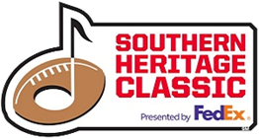

TAILGATING DECAL & PACKAGE PICKUP
All tailgate spaces go on sale Friday April 24, 2026 at 10:00am CT
online at WWW.TICKETMASTER.COM

All tailgating purchasers will receive a ticket(s) from Ticketmaster that must be exchanged for the purchased tailgating decal(s) and game ticket package(s).

*MAXIMUM OF 2 SPACES (IN ANY LOT OR COMBINED) PURCHASED PER CUSTOMER*
This package consists of all items included in your tailgating purchase through Ticketmaster; parking decal(s), game tickets, etc., and is required for load-in on September 10, 2026, and tailgating at the Classic on September 10–12, 2026.
All packages include game tickets. Please remember choice of team side is on a first-come- first- served basis only and will go quickly.
**PLEASE NOTE THERE ARE NO REFUNDS FOR TAILGATE PACKAGE PURCHASES** **THIS INCLUDES PARKING PASSES AND GAME TICKETS**

To exchange your Ticketmaster ticket for your tailgating decal(s) and game ticket package in person:

Please bring your Ticketmaster ticket to the Pipkin Building Office at 940 Early. Maxwell Blvd. Memphis, TN 38104, beginning Monday, August 10, 2026, between the hours of 9:00 AM – 4:00 PM Monday through Friday.
** If you elect to have someone pick up your package for you, please be sure they bring the original Ticketmaster ticket(s) with them.

To exchange your Ticketmaster ticket for your tailgating decal(s) and game ticket package via mail:
Please complete the attached 37th Southern Heritage Classic Tailgating Package Shipping Request Form below (Pg.4) and return it along with your Ticketmaster ticket and $30 payment for postage and handling, before Friday, August 21th, 2026 to:
Simmons Bank Liberty Stadium
335 S. Hollywood St.
Memphis, TN 38104

NO TAILGATING PACKAGES WILL BE SHIPPED AFTER FRIDAY, AUGUST 21st, 2026.

FOR OFFICE USE ONLY:

DATE ____________ # OF TICKETS _______________
TICKET PACK #(S) ASSIGNED ____________
ASU UAPB
37th SOUTHERN HERITAGE CLASSIC TAILGATING PACKAGE
SHIPPING REQUEST FORM
Please complete and return along with your Ticketmaster ticket and payment for postage and handling before
Friday, August 21, 2026 to:
Simmons Bank Liberty Stadium
335 Glenn Rogers, Sr. Street
Memphis, TN 38104
PURCHASER NAME: ______________________________________________________________________________
SPACE(S): _______________________________________________________________________________________
ITEMS TO BE SHIPPED:
- ASSIGNED PARKING CREDENTIAL(S) PER PURCHASED SPACE
- SOUTHERN HERITAGE CLASSIC PRE-PACKAGED GAME TICKETS ACCORDING TO PURCHASED SPACE
PLEASE SELECT PREFERRED SIDE:
ARKANSAS-PINE BLUFF or ALCORN STATE

- 37TH SOUTHERN HERITAGE CLASSIC TAILGATE & RV INFORMATION LETTER, INCLUDING A LIST OF PROTOCOL ITEMS PROHIBITED INSIDE THE STADIUM, AND MAPS OF OUR GROUNDS
PLEASE PRINT CLEARLY
DELIVER TO THE ATTENTION OF ___________________________________________________________________
ADDRESS _______________________________________________________
CITY ___________________________________ STATE ________________ ZIP________________________
PHONE (_____) ___________________ EMAIL ________________________________________________
** MY SIGNATURE CERTIFIES THAT I AGREE TO HAVE THE ITEMS LISTED ABOVE SHIPPED TO THE ADDRESS PROVIDED AND DO NOT HOLD SIMMONS BANK LIBERTY STADIUM OR SUMMITT MANAGEMENT CORPORATION LIABLE FOR ANY LOST, STOLEN, UNSHIPPED, OR DAMAGED ITEMS.
SIGNATURE ___________________________________________________________ DATE ____________________
PLEASE MAKE CHECKS PAYABLE TO SIMMONS BANK LIBERTY STADIUM IN THE AMOUNT OF $30.00 OR PROVIDE CREDIT CARD INFORMATION BELOW. THERE WILL BE A $35.00 FEE FOR ANY RETURNED CHECK.
CREDIT CARDS ACCEPTED (PLEASE CIRCLE): MASTERCARD / VISA
NAME ON CREDIT CARD___________________________________________________________________________
CARD # ____________________________________________________ EXPIRATION _________________________
**I AUTHORIZE SIMMONS BANK LIBERTY STADIUM TO CHARGE THE CREDIT CARD PROVIDED ABOVE FOR THE AMOUNT OF $30.00 FOR POSTAGE AND HANDLING.
SIGNATURE __________________________________________________________

37TH SOUTHERN HERITAGE CLASSIC PROTOCOL
- The holder of a purchased non-RV tailgate ticket will be issued two (2) vehicle decals and one (1) Load-In Only Pass. The holder of a purchased RV tailgate ticket will be issued one (1) decal for each RV spot purchased. These decals must be secured to the windshield of the vehicle to be valid. Only vehicles with decals are allowed in the tailgate or RV area. Decals must be secured on the windshield and Temporary Load-In Only Passes must be at all times displayed while the vehicle is on property.

- Tailgating Load-In Only Passes are good until 12:00 midnight on Friday, September 11, 2026, and are designed for drop off access only. Vehicles with a Load-In Only Pass will be allowed to drive to the designated tailgating area and drop off items. Once unloaded, the vehicle must proceed to general parking.

- Set up for tailgate purchasers begins 10:00 a.m. Thursday, September 10, 2026. On the day of the game, Saturday, September 12, 2026, tailgate set up is allowed until 12:00 noon.

- Additional Tailgating packages, without game tickets, will be sold on-site for $150 at Tobey Park, starting on Thursday, September 10, 2026, at 10am. These will be for 3-day access at the park, and are first-come, first-serve at the point entry/purchase. Payments are cashless, All parking is paid via credit card only. Visa, Master Card accepted. NO CASH.

- On Saturday, September 12, 2026, general parking will cost $20 and will open at 8:00am. No re-entry will be allowed with general parking tickets. General Parking is available in the Avery Lot located at 2540 Avery Avenue. All Parking is paid via Credit Card Only. Visa, Master Card accepted. NO CASH.

- All guests, tailgate items, cars, private portable toilets, and tents must fit within the purchased space. This includes RVs in non-RV specific lots (Lot 15)! Tailgate credentials are good for the specified tailgate space only. Individual vehicles that do not fit into the purchased space due to whatever reason must purchase a parking pass for one of the general parking lots and park their vehicles in that designated location.

- Each vehicle must be parked inside the purchased tailgate or RV area when on the property. Vehicles parked illegally or in improper spaces will be towed at the owner’s expense.

- All driveways, fire lanes, and sidewalks may not be blocked at any time. Vehicles that violate this request will be towed at the owner’s expense.

- No golf carts, ATVs, or any form of unlicensed vehicles on the property. Vehicles carrying golf carts, ATVs, or other unlicensed vehicles will not be allowed to enter the property.
- No trailers, hot ash, grease containers, equipment, supplies, or vehicles are allowed on any grass area including Tiger Lane Lawn or the tailgating grass pads at any time during the event.

- Stadium management will determine the location of public portable toilets, public ash cans, public grease/oil receptacles and public dumpsters, and they will not be relocated. No public request for portables will be allowed.

- No stakes anywhere on the property. Tents and other items must be weighted down.

- Alcoholic beverages distributed (given away or sold) to anyone under the age of 21 years old or the general public is strictly prohibited and will result in arrest and prosecution to the fullest extent of the law.
- No glass bottles.

- No live animals on property, except certified service animals or otherwise permitted by law, statute, or ordinance.

- Skateboards, scooters, roller blades, bikes, electric personal vehicles (Bird Scooters, Bikes, etc.) are prohibited.

- Under no circumstance will bicycles be allowed in any pedestrian areas or areas that permit any vehicular traffic.

- Weapons of any kind are prohibited.

- No abusive language, fighting, or engagement in violent, threatening, or tumultuous behavior or threats to any person present which creates a clear and present danger of violence.

- No damage, disturbing, or moving of personal property of another guest or any area inclusive of the Simmons Bank Liberty Stadium.

- No use of any loud, noisy, boisterous, vulgar, or indecent language or music that offends and or disturbs the peace, comfort, or enjoyment of any person.
- The use of candles or open flames is strictly prohibited in or near tents or awnings.

- Wood chips or charcoal are to be used only in cooking operations.

- All ash, coal, and grease must be properly disposed of and removed from the grounds.

- No trailers, hot ash, grease containers, equipment, supplies, or vehicles are allowed on any grass area including Tiger Lane Lawn or the tailgating grass pads at any time during the event.

- A fire extinguisher with a minimum 2A:10BC rating with a current (within one year) inspection tag on site.
- Displaying or using fireworks is strictly prohibited and may result in arrest.

- No Open flames or other devices emitting flame, fire or heat or any flammable or combustible
liquids, gas, charcoal or other cooking device or any other unapproved devices shall not be permitted inside or located within 20 feet of the tent, canopy or membrane structure while open to the public unless approved by the fire code official in accordance with Section 2404.7 of the
2009 IFC.

- All tents, awnings, and approved air-supported structures must be flame retardant. A flame-retardant certificate must be attached to the tent or on the site. A permit from the Memphis Fire Department is required for tents 120 sq. ft. and larger (any tent larger than 10’x10’).

  - Permit Fees for tents 120 sq. ft. to 1,000 sq. ft. (10’x20’ to 30’x30’) are $10.
  - Permit Fees for tents over 1,000 sq. ft. (30’x40’ and larger) are $25.
  - Permit Fees for tents rented from licensed vendors should be included in the rental fee, but it is the tailgate ticket holder’s responsibility to ensure that fee is included and displayed with their tent.
  - If the Permit Fee is not included, the Tailgate ticket holder is responsible for that cost and can purchase the permit from the Memphis Fire Prevention Office by calling 901-636-5401.

- Fire Department policy will allow participants to use one (1) 20-pound bottle of propane for cooking purposes. The bottle must be secured and not connected directly to the cooking unit. A distance of 10 to 15 feet between the cooking unit and the propane bottle is desirable. All propane bottles must be D.O.T. approved for propane use and be equipped with a U.L. approved safety relief valve, a hose in good condition, and proper connections. Participants
may have one (1) 20-pound bottle on site to use as a spare, provided it is secured and located away from any heating unit or open flame.

- All guests must adhere to the Shelby County, Tennessee, Code of Ordinances, Chapter 16, Article III – Noise Regulations. It states: Section 16-63. Playing of musical instrument or sound device. The playing of any radio, phonograph, or any musical instrument or sound device, including, but not limited to, loudspeakers or other devices for reproduction or amplification of sound in such manner or with such volume, particularly during the hours between 11:00 pm and 7:00 am, as to annoy or disturb the quiet, comfort or repose of persons in any healthcare facility or in any dwelling or other type of residence, or of any person in the vicinity is hereby prohibited. This section shall not be construed to interfere with activities of a commercial or political nature where such activity is not primarily directed toward residential areas, or healthcare facilities, and where such activity is reasonable under the circumstances. (Code 1992, § 19-43; Ord. No. 168, § 1(3), 10-23-1995) 5

- If any displays, props, decorations, materials or other personal property, are used it must fully comply with the Fire Code of the City of Memphis, i.e., all wiring on booths or display fixtures must meet the rules and standards of the City of Memphis Board of Fire Underwriters and Fire Department. Among other precautions, cloth, paper decorations, pine boughs, leaves, tree branches, and all other decorations must be flameproofed. Use of combustible material is forbidden. Any hazardous substance, explosives, gasoline, kerosene, acetylene or other fuel or combustibles are strictly prohibited.

- Stadium management reserves the right at all times to refuse admission to or to cause to be removed from anywhere on the footprint of Simmons Bank Liberty Stadium property any disorderly or undesirable person, as determined by the stadium management in its sole discretion, and in the event of the exercise of such authority, the event sponsor and disorderly or undesirable person hereby waives any and all claims for damages against the stadium management.

PROHIBITED ITEMS

Guests to Simmons Bank Liberty Stadium are prohibited from entering the stadium with the following:

- Bags not compliant with the stadium’s Clear Bag Policy (small clutches & purses permitted, 5”x7”; clear bags & totes only, 12” x 6” x12” maximum size). Please See Clear Bag Policy
- Baby Strollers
- Chair backs larger than a single seat (a maximum of 18" wide, 12" deep with arms)
- Umbrellas
- Cameras with lens greater than 12” and audio or audio/visual recording devices
- Laptop computers, televisions, or any device that may interfere with technology-related services provided by the stadium or for its use.
- Briefcases, backpacks, cinch bags, luggage of any kind, computer bags, camera/video recorder bags
- Air horns or any other artificial noise makers other than those approved by the playing teams or their respective conferences.
- Animals (excluding service animals, those approved for shows, entertainment, etc.)
- Fireworks or other explosives
- Laser pens or laser products of any type
- Coolers/Ice Chests
- Outside food or beverages of any kind (alcoholic beverages included) except for medical or infant needs
- Glass, plastic, aluminum & liquid containers
- Poles or sticks
- Balloons, confetti, glitter, objectionable banners, or device that may interfere with and/or distract any sports or event participant or stadium guest.
- Projectiles of any type including Frisbees, baseballs, and beach balls
- Mask or costumes other than those in support of the playing teams excluding any Stadium Management approved themed events.
- Weapons of any type, including guns and knives
- Drones or Remote-Controlled Model Aircraft (RCMA)
- Any other item deemed unacceptable by Stadium Management

CLEAR BAG POLICY

To provide a safer environment for the public and significantly expedite guest entry into the stadium, Simmons Bank Liberty Stadium has a bag policy for all ticketed Stadium events that limits the size and type of bags that may be brought into the venue.
Guests will be able to carry the following style and size bag, package or container into the venue:
- Bags that are clear plastic, vinyl or PVC and do not exceed 12" x 6" x 12."
- One-gallon clear plastic freezer bag (Ziploc bag or similar).
- Small clutch bags, approximately the size of a hand, with or without a handle or strap can be taken into the venue with one of the clear plastic bags.
- An exception will be made for medically necessary items after proper inspection.
Prohibited bags include but are not limited to: purses larger than a clutch bag, briefcases, backpacks, fanny packs, cinch bags, luggage of any kind, non-approved seat cushions, or seatbacks * (see below) computer bags, diaper bags, binocular cases, and camera bags.
Guests will continue to be able to enjoy their tailgate activities in the parking lots and to do so with greater safety and the knowledge that their entry into the venue will be smoother and faster. They also will continue to be able to carry items allowed into the venue, such as binoculars, cameras, and smart phones.
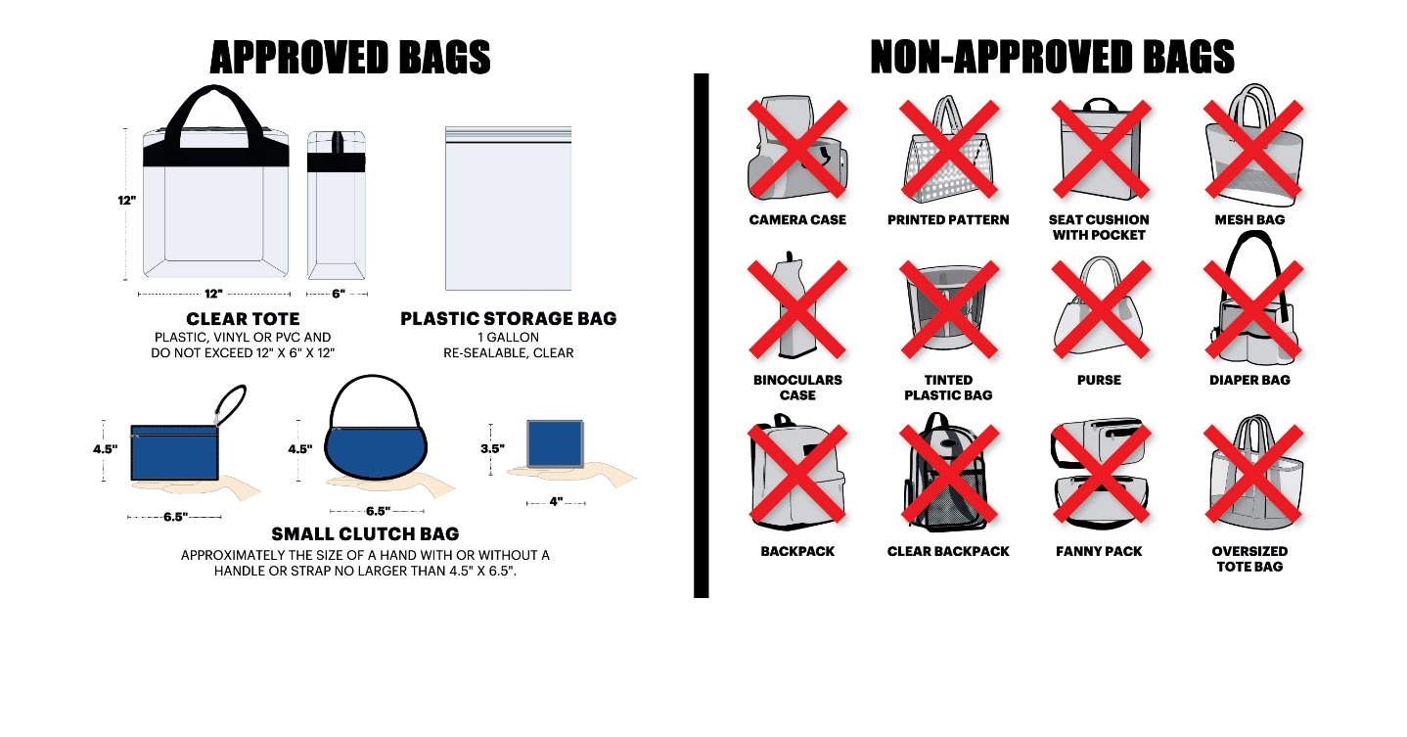
*Non-approved seat cushions and seatbacks include large traditional seat cushions that have pockets, zippers, compartments, or covers. Seat cushions and seatbacks must be 18” or less in width with no armrests.

BAG POLICY FAQ

Why did the Stadium adopt this policy?
This is about both safety and improving the overall fan experience. Simmons Bank Liberty Stadium frequently reviews its public safety and stadium security policies looking for ways to improve them. The most recent review concluded that there is a need to adjust our policy to enhance public safety and make stadium access more efficient by limiting the size and style of bags carried into the stadium. This proactive measure will enhance safety inside and outside the stadium and speed the security screening process for all fans. The public deserves to be in a safe, secure environment.

Are other Venues limiting bags?
Yes. In 2017 The SEC, Big 10 and Big 12 mandated a conference wide clear-bag policy. The NFL policy, which Simmons Bank Liberty Stadium’s policy resembles, has been in place for several years. The approved bag size and style is a further step toward convenience and safety.

How does the new policy improve public safety?
The clear bag is easily and quickly searched, reducing faulty bag searches. It also supports the Department of Homeland Security's "If You See Something, Say Something" campaign.

How does this make it more convenient for fans?
It is hoped that this will enable us to move fans through our security check points much faster, as it has at other venues where it has been implemented. A standard bag size simplifies the search process, making stadium security’s job much easier, allowing staff to be more efficient and effective in checking bags at points of entry. It is hoped that there will be less time spent standing in lines at the stadium gates and fans will be able to be in their seats well before kickoff. Shorter lines mean fewer hassles. Also, it is hoped that fans will enjoy an improved sense of safety.

How many bags can each person bring into the stadium?
One large clear bag – either a one-gallon Ziploc style bag or the 12" by 6" by 12" clear bag – plus a small “clutch" purse, no larger than 4½" by 6½". The larger clear bag must be a standard 12" by 6" by 12" made of clear PVC vinyl. The one-gallon Ziploc bag is readily available, inexpensive and easy to search. The small “clutch" allows privacy for small personal items and also is easily searched.

Can fans carry cameras, binoculars, smart phones or tablets separately from what they put in a clear bag?
Yes. Binoculars, phones or cameras may be carried into the stadium, but no cases or bags will be allowed. This new policy is not a restriction on items that fans have been able to bring into the stadium. It is only a restriction on the type of container used to carry those items.

Are seat cushions allowed to be carried into the stadium?
Only approved seat cushions may be carried into the stadium. Large traditional seat cushions that have pockets, zippers, compartments, armrests, or covers are not permitted. Small seat cushions and seat pads without pockets, zippers, compartments, or covers are permitted.

What about bringing blankets in cold weather?
Fans will be able to bring blankets by tossing them over a shoulder or arm as they arrive at the gate. These items can be screened easily.

Are all purses prohibited?
No. Unlike some event venues, not all bags are banned. Small “clutch" purses, no larger than 4 1/2" by 6 1/2", with or without a handle or strap, are permitted along with either the 12" by 6" by 12" clear tote bag or the one-gallon freezer bag. This should enable fans to carry the same items they have in previous years while providing for quick entry into the stadium because it will take less time to screen bags. Shorter lines mean fewer hassles. We encourage fans not to bring any bags, but we have created a policy that balances the needs of spectators with improved public safety and convenience.

Do I have to put everything I'm carrying into the permissible bags?
No. We are only limiting types of bags that may be carried into the stadium, not the items normally brought to a game. Therefore, fans may carry (in their pockets or jackets) keys, makeup, feminine products, combs, phones, wallets, credit cards, etc., if the spectator chooses not to put them in a clear bag or clutch. Spectators also can carry a blanket over their arms, binoculars and/or camera around their neck or in their hands without a case. Spectators can use clear bags and clutch to carry other items. They will continue to have the flexibility to bring a wide variety of approved items into the stadium. Every member of a family may carry in their own permissible bag.

What about diaper bags?
Diapers may be carried in a permissible 12"x6"x12" clear bag. Each member of a family, including children, will be allowed to carry an approved clear bag and a clutch purse into the stadium.

If I have medical bag or special medical equipment, I need to have with me at all times, where do I put that?
An exception will be made for medical necessary items after proper inspection at specified stadium gates. ALL TICKETED GUESTS NEEDING MEDICAL BAG EXCEPTIONS PLEASE ASK FOR THE GUEST RELATIONS SUPERVISOR AT YOUR ENTRY GATE.

Will this policy affect the ability of fans to tailgate? Are there limitations on tailgating items?
No. Fans will be able to enjoy tailgating activities on Tiger Lane and in parking lots and can do so with greater safety and knowledge that entry into the stadium will be smoother and faster.

In the event any of these items are revealed during a search, guests must dispose of the items or return the prohibited item to their vehicle prior to entry. If you have any questions, please contact the Stadium Office at 901.678.4975 prior to the event.

PLEASE ENJOY THE GAME DAY EXPERIENCE!

For additional assistance please call 901.398.6655 or 901.678.4975
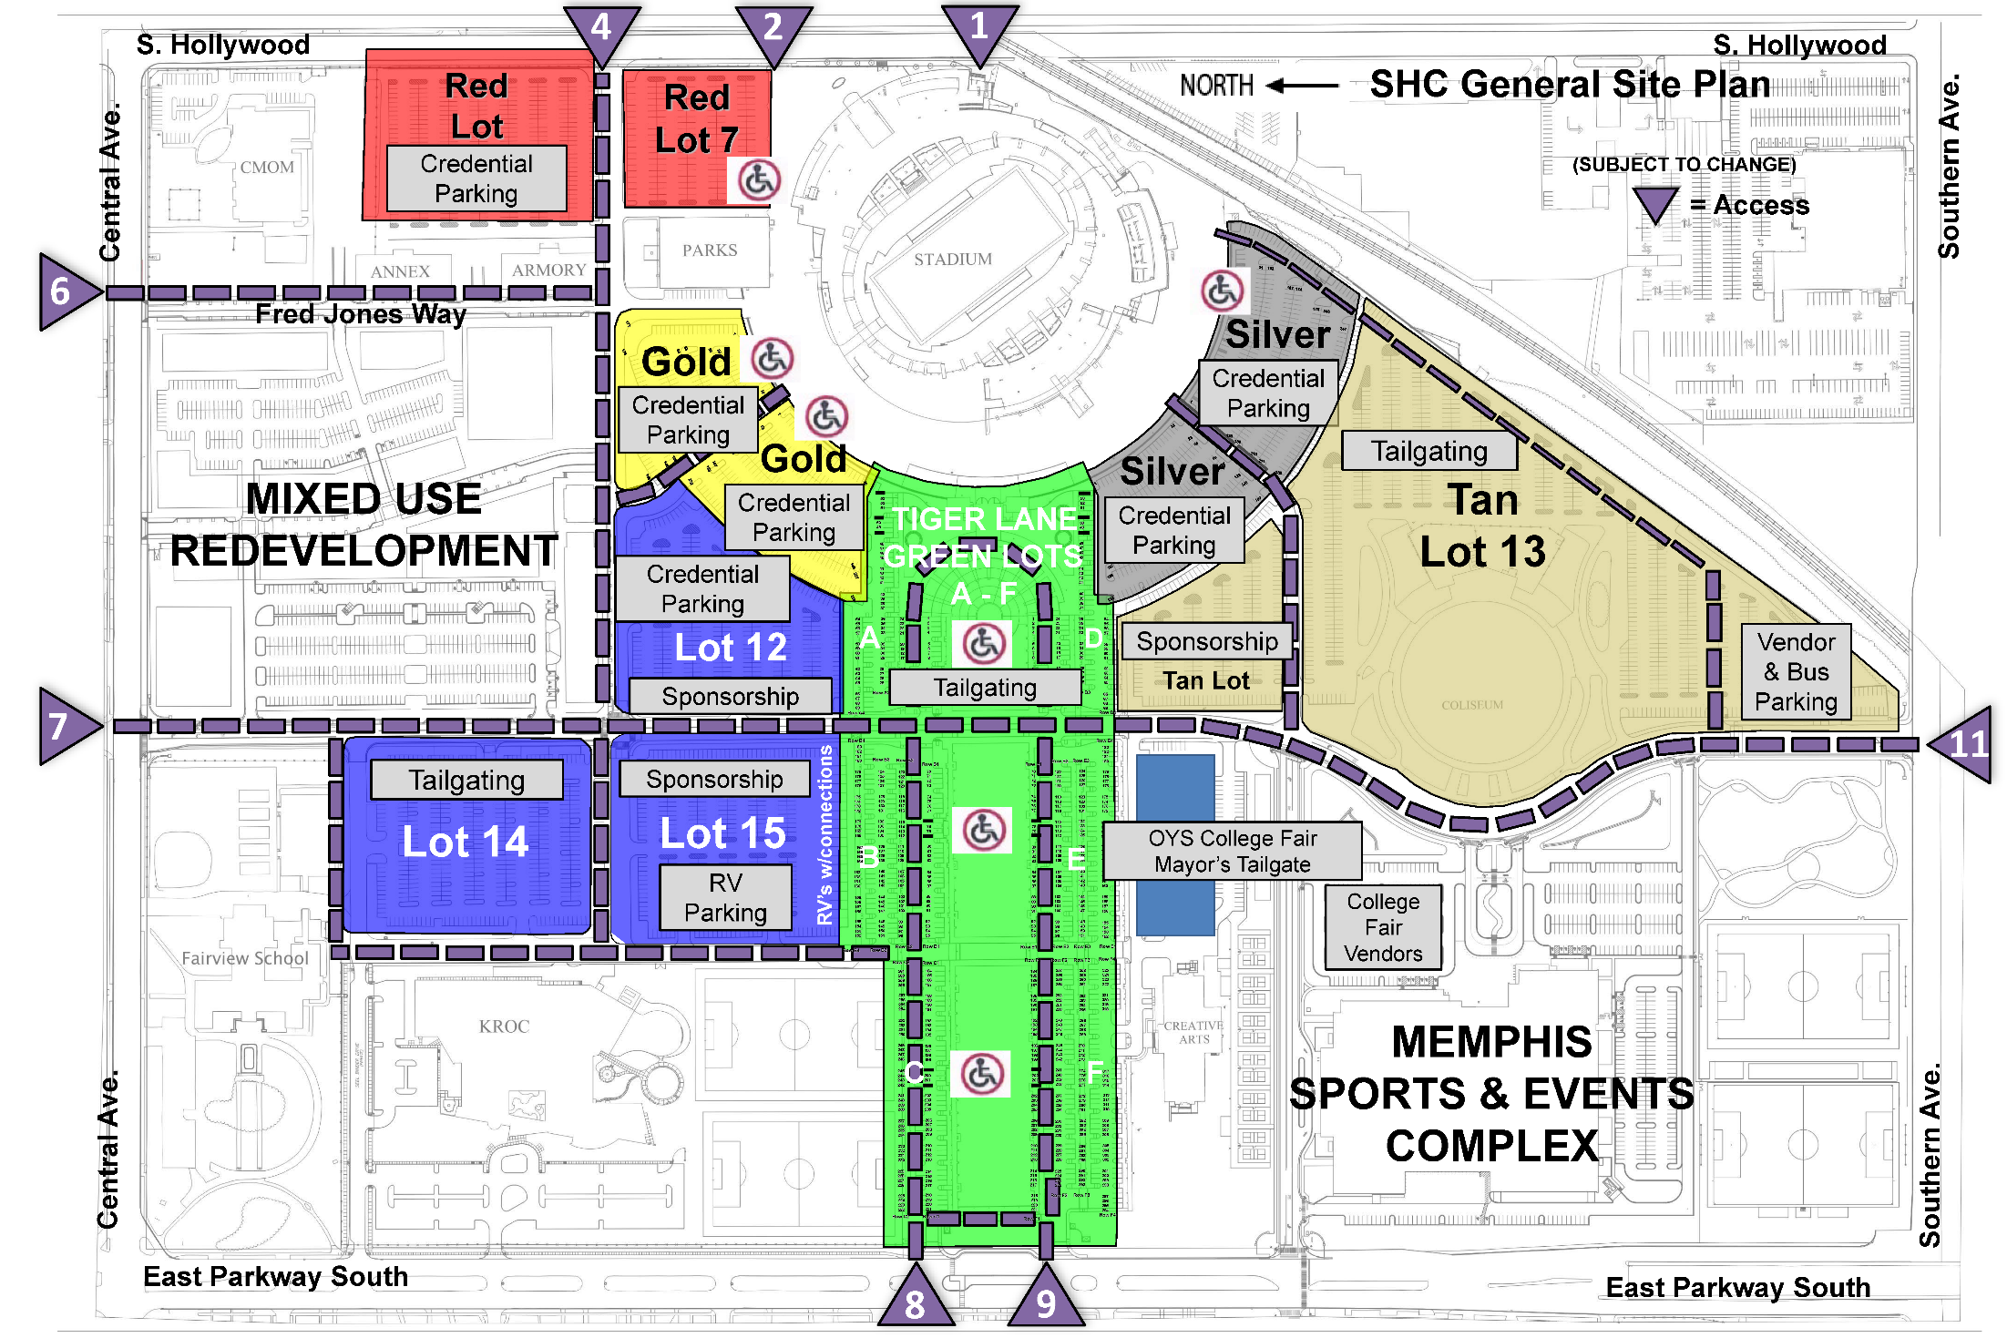
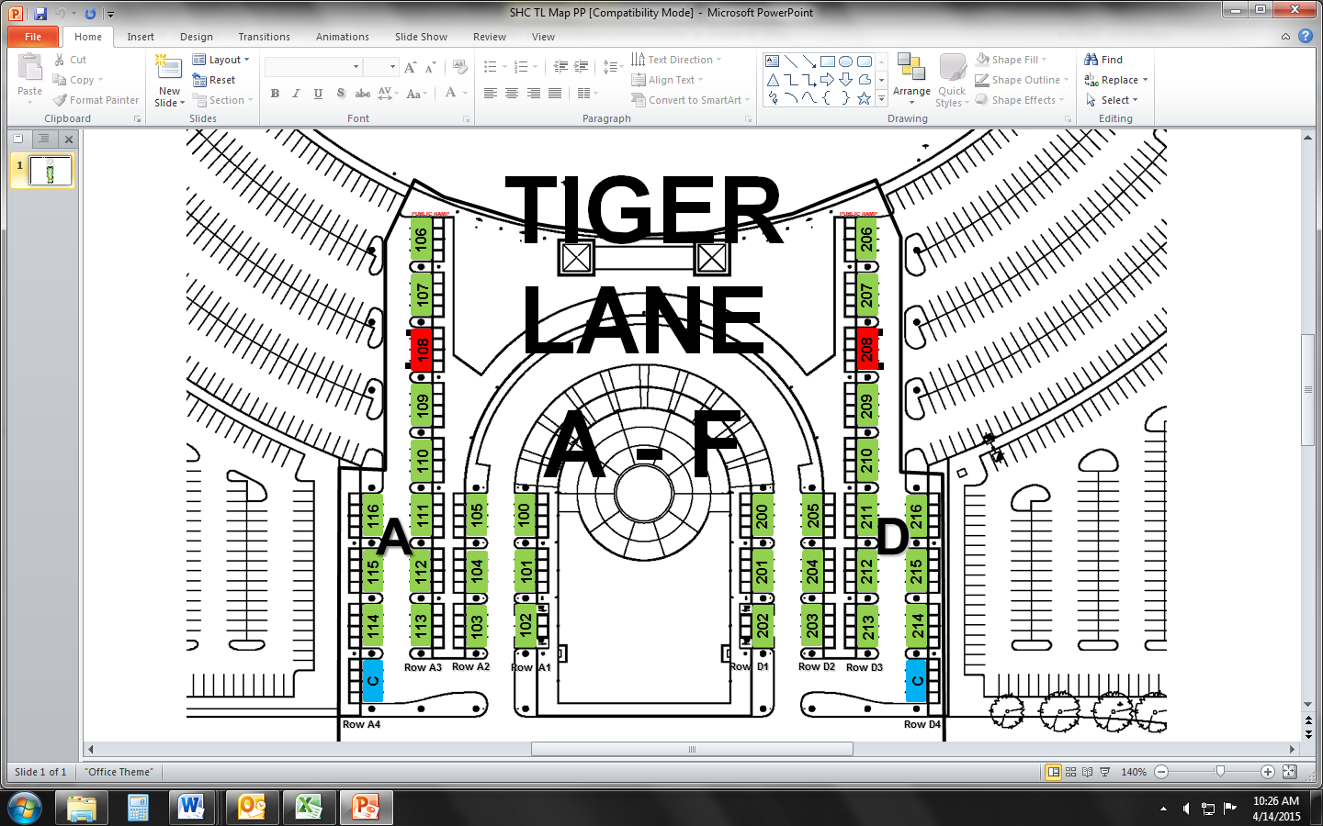

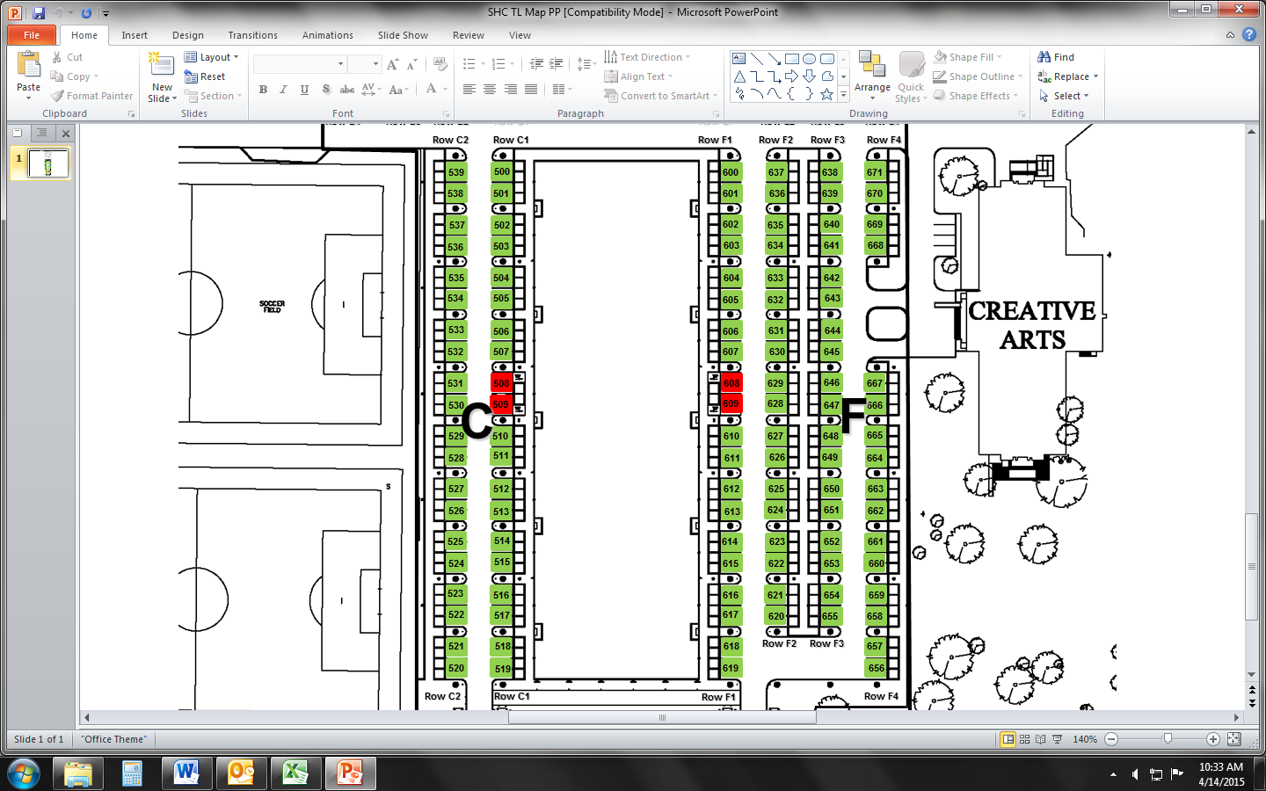
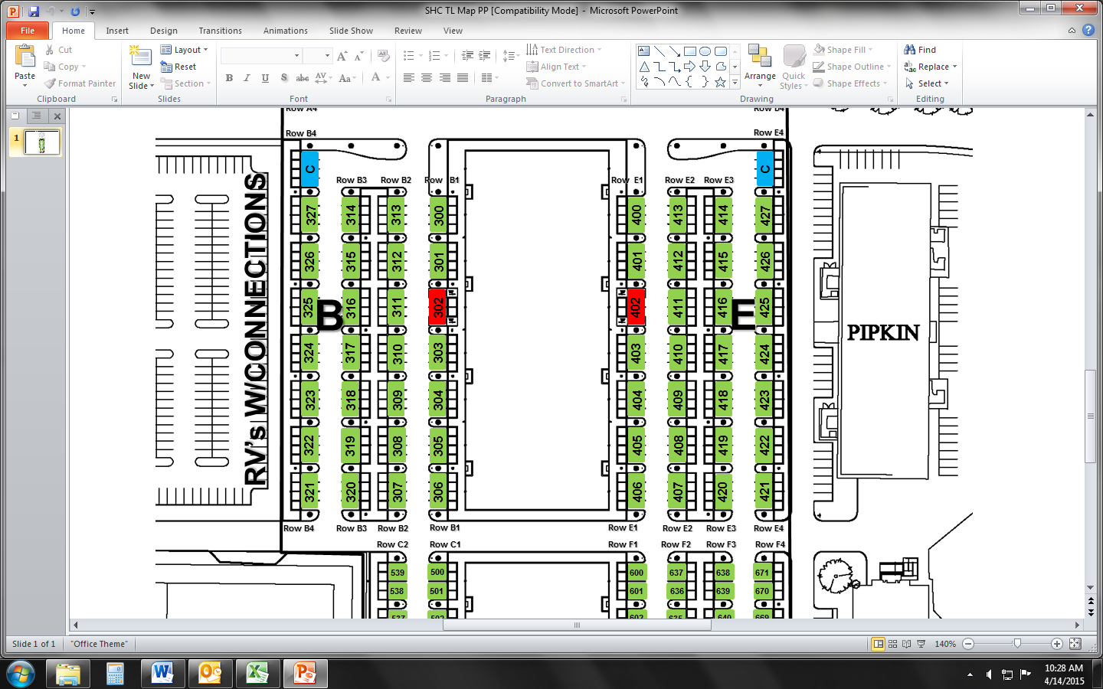
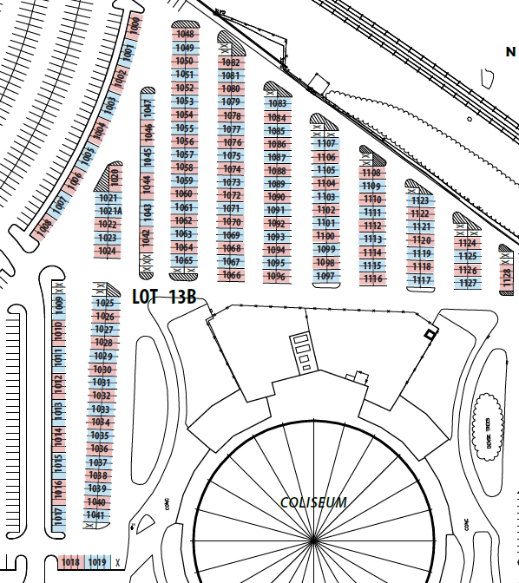

Tan LOT - SOUTH
LOT 14 - NORTH & RV LOT 15 - NORTH

